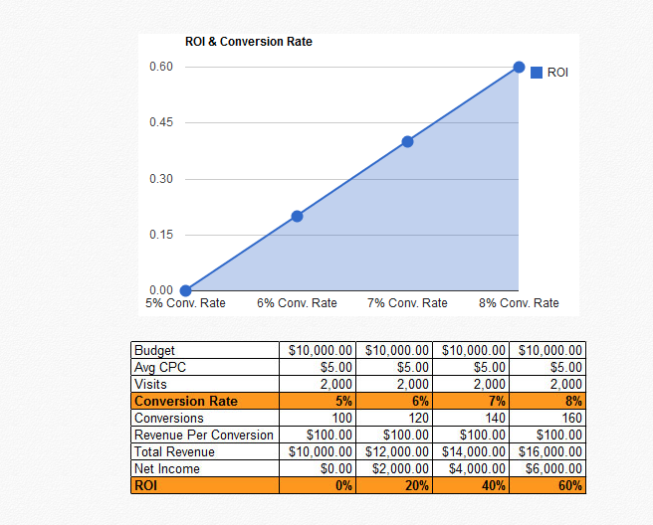

Best times for seeing clicks/conversions

What Is the Average Click-Through Rate for a PPC Ad?

The average click-through rate on AdWords paid search ads is about 2%. Accordingly, anything over 2% can be considered an above average CTR.

