Alternatives to Hootesuite

https://sproutsocial.com/ - (Free Trial) £99+ per month

What sets Sprout Social apart:
- In-depth analytics connected with Google Analytics
- Brand monitoring
- Reporting capabilities at no additional cost
- Integrated social media image editor

https://www.socialoomph.com/ - Free - £17.99

What sets SocialOomph apart:
- Schedule and publish blog posts from unlimited sources
- Advanced direct message management to filter out spam
- Unlimited accounts—even with free version
- Auto-responder functionality

https://www.sprinklr.com/ - (Free Trial)
- Social content includes Facebook apps, polls, quizzes, social ads, and web apps
- Content translation available for international reach in over 70 languages
- In-depth analysis with customized and exportable reports
- Goes beyond just posting content—monitor and listen to all your social channels

https://www.socialpilot.co/
- Integrate your iOS App Store and Google Play Store accounts
- Flexible schedules for posting and campaigns
- Google Chrome plug-in with Bitly integration
- 300+ supported apps

https://sendsocialmedia.com/
- Ability to combine social media, email, and SMS capabilities in one single platform
- In-depth analytics and monitoring for additional social networks such as Yelp and Citysearch reviews
- Can also be used as a CRM

http://keyhole.co/
- Hashtag and Keyword tracking - Free Trial

https://www.agorapulse.com/
Engage
Reply to all your conversations in one place.
Publish
Post content according to your schedule.
Listen
Monitor all relevant social conversations.
Collaborate
Share your social management responsibilities.
Measure / Report
Track the power of your social content.
Audience
Build meaningful relationships with your followers

https://www.brandwatch.com/

https://buffer.com/ - FREE - £399 per month
- The ability to schedule posts to your Pinterest account for paid plans
- RSS feed integration for all paid plans
- Preset your posting times for each platform, profile, and day of the week in advance
- Share relevant web content with your audience in one click while browsing with the browser extension
- The Pablo extension allows users to easily overlay text on images

http://buzzsumo.com/

https://meetedgar.com/

Twitter

https://tweetdeck.twitter.com/

What sets TweetDeck apart:
- Can be downloaded as desktop software
- No limit to the number of Twitter accounts used
- Option to set up audio and pop-up notifications
- Completely free
- Can be combined with Buffer

How to set-up a Hootesuite account

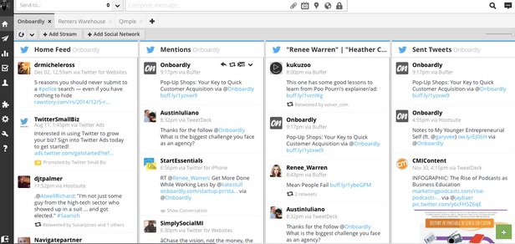

Step 1: Create a Hootsuite account
- Open https://hootsuite.com and click Sign Up in the top-right corner.
- Click to select the plan type that fits your needs.
- Enter your information and follow the prompts as we walk you through connecting social networks, adding streams and sending messages.

Step 2: Add social networks
Connect your social profiles to publish and schedule content, and monitor engagement, all from your Hootsuite dashboard. You can manage up to three social networks with Hootsuite Free.
- In the Hootsuite dashboard, select Streams from the launch menu.
- Click Add Social Network, select a social network from the list, click Connect and authorize your accounts to connect to the dashboard.
See Add social networks for more details.

Step 3: Set up tabs and streams
Now that you’ve added social networks to your dashboard, set up streams for each one to monitor conversations and engage with customers. Each social network offers unique stream types. Search streams are especially valuable for finding social activity around specific users, locations, or keywords. Use tabs to organize your streams into groups.
- Select Streams from the launch menu.
- Click Add Tab in the top-right corner, give it a name, and then press ENTER.
- Inside each tab, click Add Stream.
- Select a social network from the list on the left, and then select a profile from the drop-down list.
- Click the streams you want to add for that profile.
See Add tabs, Add streams, and Add search streams for more details.

Step 4: Publish messages
Engage your audience and grow your following by regularly publishing messages. Save time by scheduling a single message to multiple social networks at once.
- Select the profiles that will post the message from the Social Profile Picker (top-left).
- Click Compose Message, enter your message in the compose box, and then click Send Now.

Creating, Uploading and Scheduling Your Content
At the core of it, Hootsuite is a tool for managing content and there are a few different options available to you for creating and uploading materials to the dashboard. First, you can simply use the compose box (pictured below), which allows you to:
- Post to multiple networks at once.
- Add (and shorten) links.
- Include a location.
- Add attachments to your messages.
- Schedule posts for later.
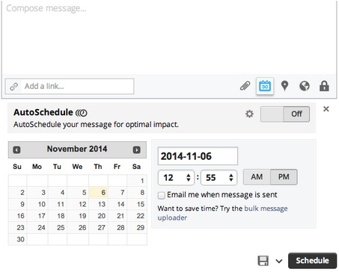
A second option for adding content to the dashboard is to use the bulk message uploader (available in Pro and Enterprise plans). This allows you to create the content in a spreadsheet (up to 350 messages) and upload them all at once. Regardless of whether you craft messages one-by-one or in batches, a great tool to make use of is the scheduler.
Again, you can schedule them individually in the free version or in bulk if you have a paid plan. The paid options also give you access to Publisher, where you can review all your scheduled content and make adjustments.
If you’re thinking, “That’s great Shanelle, but where am I supposed to come up with 350 messages worth of content”, I have two tools you’re going to want to check out:

Step 5: Install apps
The Hootsuite App Directory is a library of free and premium (paid) third-party apps developed to extend the functionality of the Hootsuite dashboard.
- Select App Directory from the launch menu.
- Click Install App beside the app.
- Click Finish.
See Install Apps for more details.

Step 6: Download Hootlet
This free browser extension for Chrome lets you quickly share content to your social networks from anywhere on the web. Get it here. Learn more about using it here.

Step 7: Download Hootsuite mobile
Manage your social media on the go with the Hootsuite mobile apps for Android and iPhone, iPad & iPod Touch. These can be downloaded from your device's app store.
Hootsuite is also available for mobile web at https://m.hootsuite.com.

Step 8 (Team Plan): Collaborate with team members
Invite team members, share social network access with them, and start collaborating. Check out our quick start guide for teams to learn how.

To create an analytics report or draft

- Select Analytics from the launch menu.
- Under Customize, click Build Custom Report.
- Select Custom Report (or a report template).
- Click to select the report owner (organization name) at the top of the screen.
- Click Hide Personalized Header to hide header and skip to step 6, or click Upload Image, select an image and then click Open.
- Click on the details in the far-right corner of the header to edit them.
- Click and delete Type a Header here, and enter your new header.
- Under Details in the top-left corner, enter the title of your report and a brief description.
To have this report emailed to all members sharing the report, check the box.
- Under Analytics Modules, click a social network, and then click a module to add it to your report. Click Remove in the top-right corner of the module to remove it from your report.
Hover over each module for a brief description of its functionality and the points required for its use.
- Enter the information required in that module such as title, keyword, or selecting a social profile, and then click Done. The social profile selected must belong to the organization selected in step 4.
Repeat steps 9 and 10 to add additional modules.
- Click Create Report or Save as Draft.

To create an analytics report as a team member
- Select Analytics from the launch menu.
- Under Customize, click Build Custom Report.
- Select Custom Report.
- Click the points counter at the top of the screen to change the organization.
- Click Please select a report owner, and then select the organization under which you will create the report.
- Customize and add modules to your report (see steps 8 to 10 listed above).
- Click Create Report.

