How do I create a Facebook ad?
You can create a Facebook ad using ad creation in Ads Manager
To do this:
- From Ads Manager, click Create Campaign.
- Choose an advertising objective. For example, if you want to create an ad to increase traffic to your website or get more people to download your app, select Traffic under the Consideration column. Learn more about choosing advertising objectives.
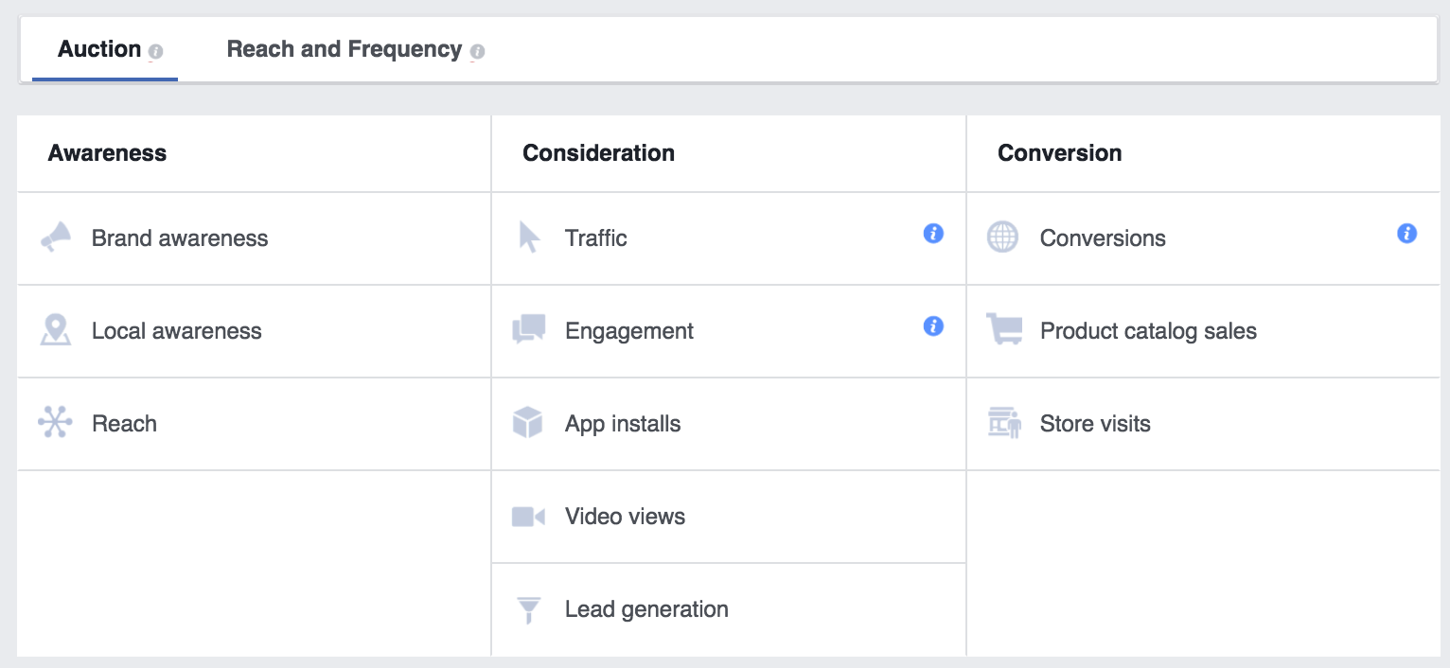
- Click Continue. In the next steps, you can choose to advertise your Page, business, website, or event and then choose the audience, budget, images and text for your ad before placing your order.
How should your story be told?
- Whether you want to use video, photo or text – or a combination of those elements – there's a Facebook advert format for every story. Our advert formats put your business goal front and centre, and they look great on every device and connection speed.

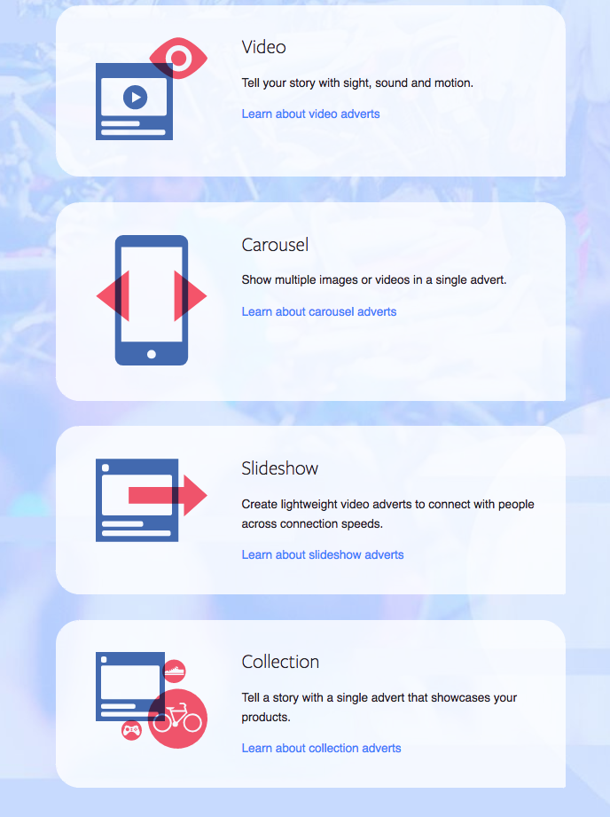

https://www.facebook.com/business/learn/facebook-create-ad-basics/

