Step #1. Advertising on LinkedIn
LinkedIn’s self-service solutions lets you launch a targeted campaign in minutes. You can set your own budget, choose clicks or impressions, and stop your ads at any time using Campaign Manager, LinkedIn's all-in-one advertising platform. Ad formats supported in Campaign Manager are Sponsored Content, Sponsored InMail and Text Ads.
Dynamic Ads are also available through account-managed adertising, which allows you to partner with a dedicated LinkedIn team to create exclusively placed, highly visible ads for premium audiences.

Step #2. Get Started with Campaign Manager
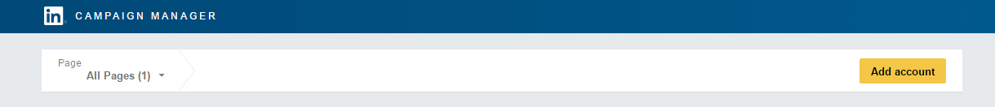
Get started by signing in to Campaign Manager. If you don’t have an account, you can create one in minutes.
Campaign Manager is where you will manage and optimize your advertising on LinkedIn. It includes several features designed to help you meet your advertising goals:
- Dynamic visual reporting that recalculates and displays only the data that matches your search and filter settings.
- A detailed breakout of the actions your Sponsored Content campaigns generate, including Clicks, Likes, Shares, Comments, and Follows.
- A detailed view of the demographic categories of LinkedIn members who click on your ads, available at the account, campaign, and creative level.
Related: Setting up a Campaign Manager account

Step #3. Choose Your LinkedIn Ad Format
Now that you are logged in to Campaign Manager, it’s time to create and manage your ad campaigns. You can use Sponsored Content, Sponsored InMail, Text Ads, or a mix of all three. Before we get into actions, here’s a quick breakdown of each option:

Sponsored Content
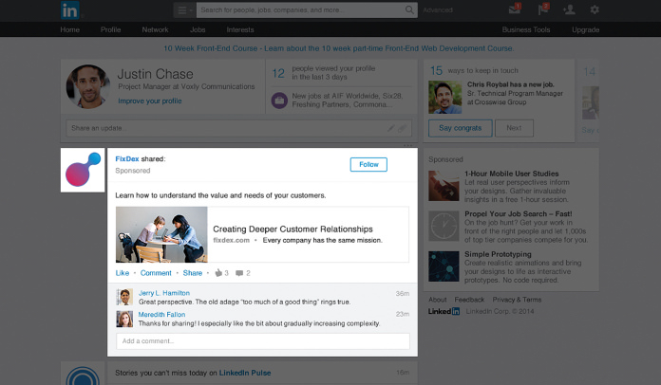
Sponsored Content is native advertising that appears directly in the LinkedIn feeds of professionals you want to reach. Using Sponsored Content, you can:
- Get your message out on every device: desktop, tablet, and mobile
- Use rich media to stand out in the feed
- Easily test your messaging and optimize campaigns in real time
Learn more about Sponsored Content

Sponsored InMail
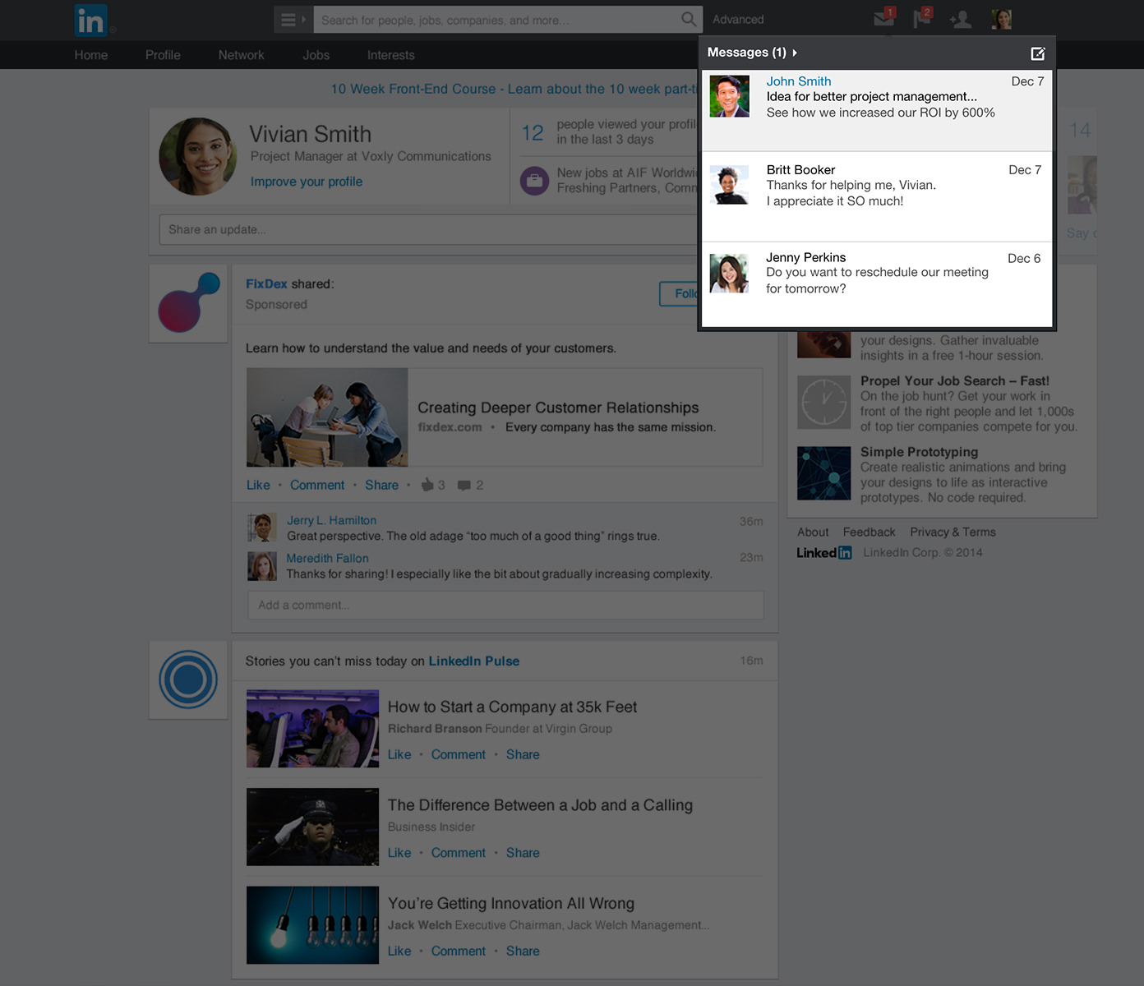
Sponsored InMail is a unique ad format that lets you deliver personalized, relevant content through LinkedIn Messenger. Using Sponsored InMail, you can:
- Drive conversions with personalized messages
- Reach targeted audiences on desktop and mobile
- A/B test messaging to resonate with your target audience
Learn more about Sponsored InMail

Text Ads
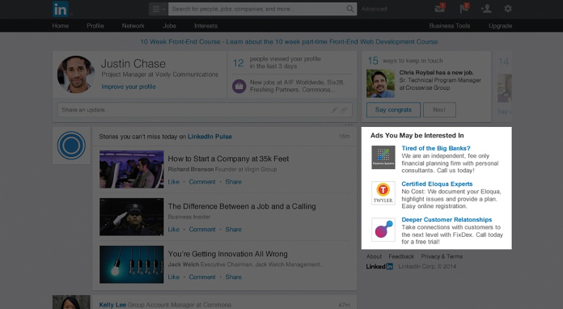
Text Ads are simple but compelling pay-per-click (PPC) or cost-per-impression (CPM) ads. Using Text Ads, you can:
- Easily create your own ads and launch a campaign in minutes
- Tailor messaging to the professionals you need to reach
- Pay for only the ads that work – per click or per impression
Learn more about Text Ads
In Campaign Manager, select the account you’d like to use, then click the Create Campaign button.
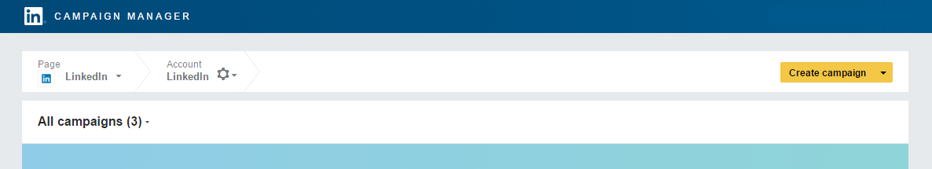
Then choose from Text Ads or Sponsored Content.
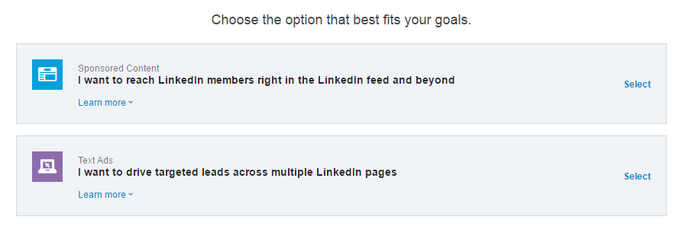

Step #4. Create Your Ads

Create Sponsored Content
Once you’ve selected Sponsored Content, you will have three options:
- Choose an update from your LinkedIn Company Page to sponsor
- Choose an update from your LinkedIn Showcase Page to sponsor
- Create new Sponsored Content
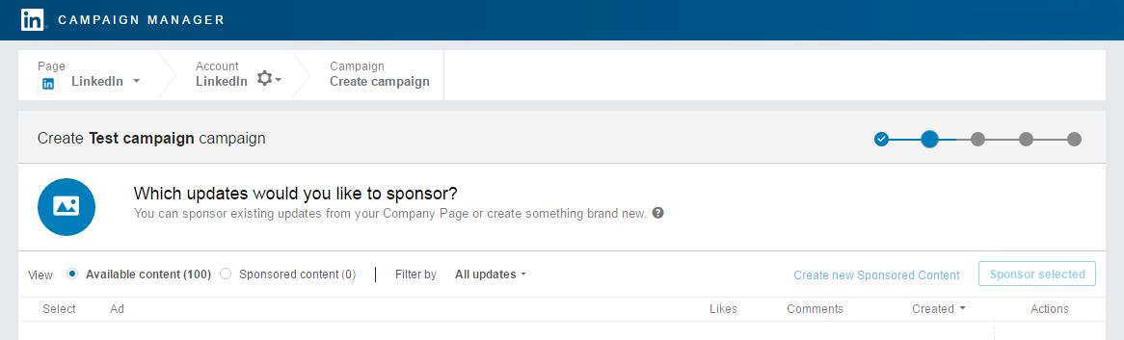
If you want to edit an existing update to customize it for a target audience, choose to create new Sponsored Content. It’s a good idea to create multiple variations of Sponsored Content so that you can see which messages get the best results. You can use a variety of messages, links, photos, and images to see what works best.
To add rich media, click the paperclip icon in the upper right corner of the text box.
Once you’ve created your ad, you can view a preview before saving. If everything looks good, select the content you want to promote within your campaign and click the Sponsor selected button.
Click Next.

Create Sponsored InMail
Once you’ve selected Sponsored InMail, enter a campaign name and choose a language for your ads. You will have several options:
- Choose the sender. The sender’s first name, last name and profile image will appear in the recipient’s inbox along with the subject line of the message.
- Add message subject line and summary. The summary will give your recipients a sneak preview of your message on desktop.
- Craft your message. You can add easy personalization (like the recipient's first name) right in the tool.
When crafting your Sponsored InMail message content consider the messaging context of the LinkedIn Platform.
Keep your subject lines concise, relevant and conversational. Short and impactful subject lines with a clear value exchange work best. Consider utilizing some of the following keywords:
- Thanks
- Exclusive invitation
- Connect
- Opportunities
- Join us/me
Humanize your message with conversational language and aim to keep your copy under 1,000 characters.
Click Next, and add your landing page URL and optional hero banner image.
Click Next.

Create a Text Ad
Once you’ve selected the Text Ads option and named your campaign, you can start creating your ad.
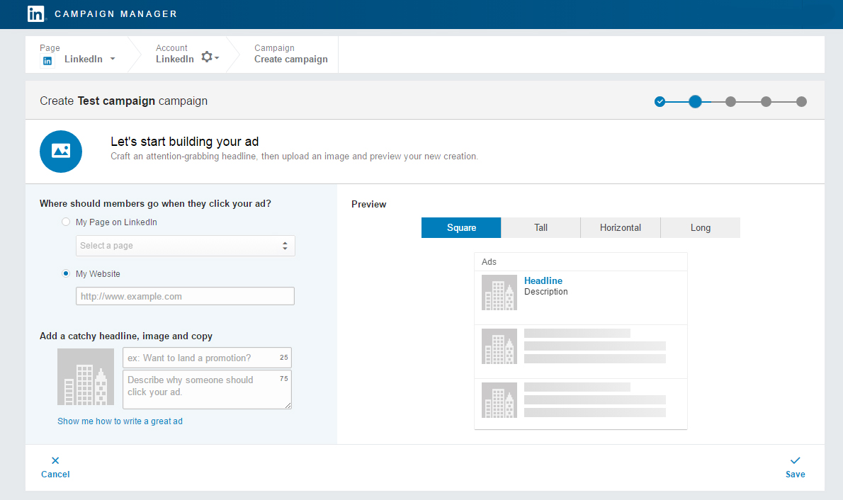
First, decide where members should go when they click your ad, whether it’s your page on LinkedIn or a specific page on your website. Next, add your image, a headline (up to 25 characters), and a description (up to 75 characters). As you create your ad, you will see a preview on the right side of the page.
You can create up to 15 Text Ads to see which headlines, descriptions, and images get the best results.

Step #5. Target Your Ads
Selecting your audience works the same way regardless of whether you choose Sponsored Content, Sponsored InMail or Text Ads. After you’ve created your ad, you will be taken to the following screen:
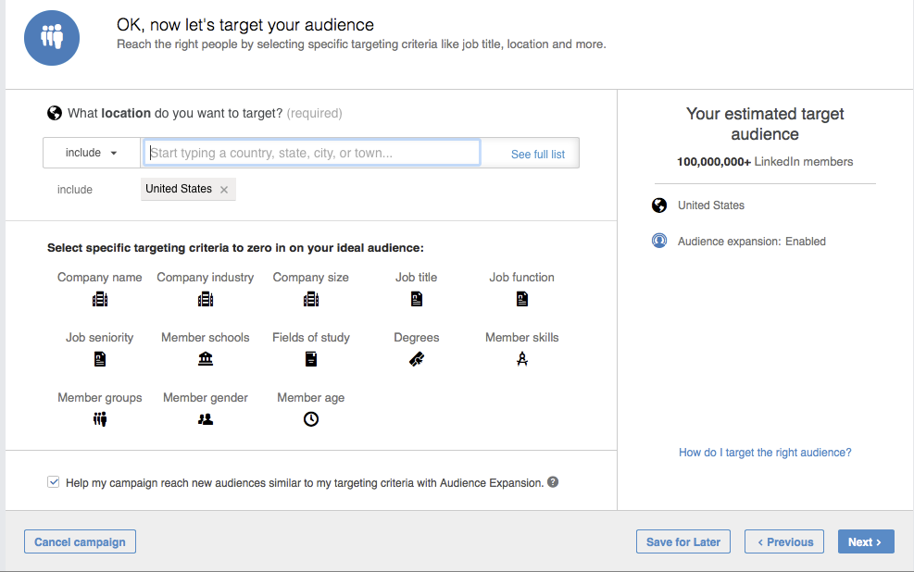
As you can see, there is a wide variety of criteria you can use to select your ideal audience. As you select additional criteria, you will see how each additional filtering option affects your estimated target audience size in the right sidebar.
You will notice additional options below the targeting criteria.
- Audience Expansion automatically includes audiences similar to those you’ve selected. This helps to ensure you’re not missing out on relevant engagement opportunities, especially early in your campaign.
- You can also choose to deliver your campaign to your target audience beyond the LinkedIn feed, using LinkedIn's network of partner audiences.
Related: LinkedIn Advertising 101: Targeting

Step #6. Set Your Budget
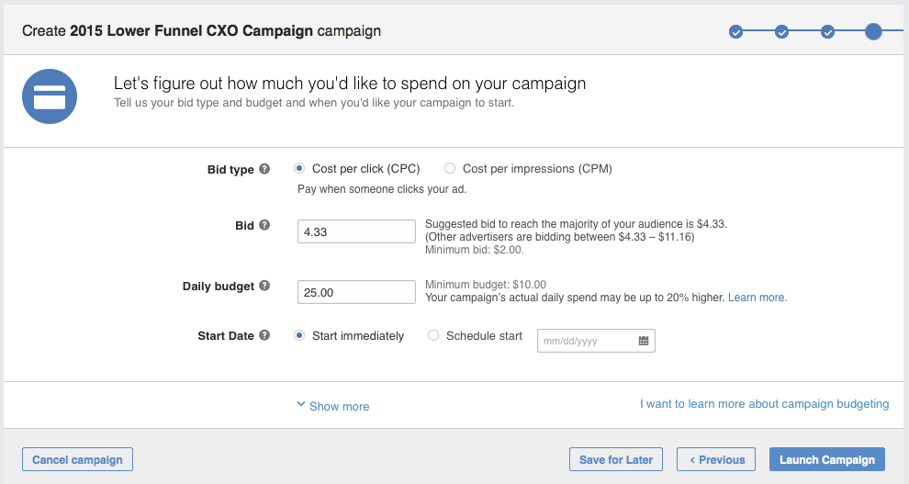
Now that you’ve selected your audience, it’s time to set the budget for your campaign. There are three options: cost per click (CPC); cost per impression (CPM); or cost per send (CPS).
Cost per send (CPS) is used when you run Sponsored InMail campaigns. You pay for each InMail that is successfully delivered.
CPC is often used for action-oriented campaigns like lead generation or event registration, whereas the CPM model is typically a better fit when brand awareness is the goal.
Along with choosing between CPC and CPM, you will also enter your suggested bid, daily budget, start date, end date, and total budget. Regardless of the end date you choose, you can cancel your campaign at any time. It’s also important to note that LinkedIn uses an auction system for bidding that rewards engagement, meaning you can win an auction without being the highest bidder.
Related: LinkedIn Advertising 101: Bidding

Step #7. Measure and Optimize Your Campaign
Congratulations, your LinkedIn advertising campaign is live! Now it’s time to see how your ads are performing. You can access your analytics by visiting Campaign Manager and selecting the campaigns you want to evaluate.
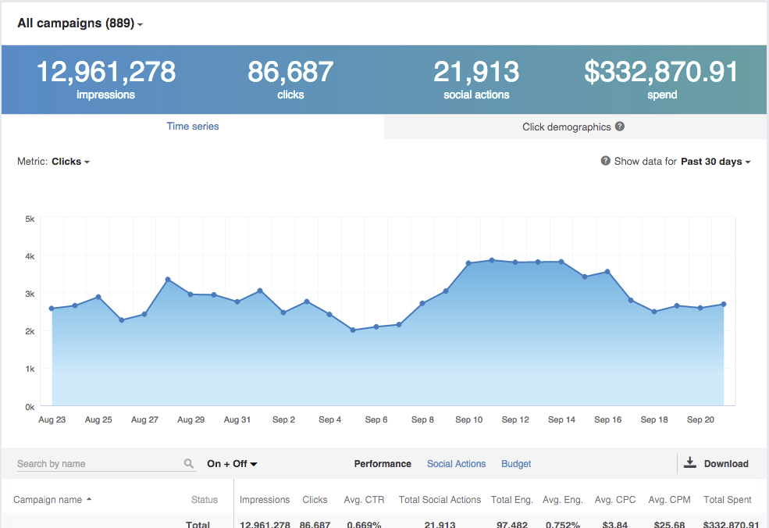
In addition to overall performance, you can also see how your campaigns are performing as it relates to social actions and budget. Social actions are initiated by LinkedIn members who interact with your content – it’s organic, free engagement.
Click through to each campaign to see how each ad within the campaign is performing. Using this data, you can edit your ads, refine your targeting, adjust your budget, and toggle ad variations on and off based on performance.

