Record a slide show with narration and slide timings
Narrations and timings can enhance a web-based or self-running slide show. If you have a sound card, microphone, and speakers, and (optionally) a webcam, you can record your PowerPoint presentation and capture narrations, slide timings, and ink gestures.
After you have made the recording, it's like any other presentation that can be played for you or your audience in Slide Show—or you can save the presentation as a video file.
Using PowerPoint on a Mac? See Record your slide show in PowerPoint 2016 for Mac or Record your slide show in PowerPoint for Mac 2011.
Office 3652013, 201620102007
- With your presentation open, on the Slide Show tab, click Record Slide Show.
  - Clicking the upper half of the button starts you on the current slide.
  - Clicking the lower half of the button gives you the option to start from the beginning or from the current slide.
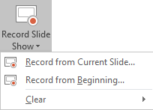
(The Clear command deletes narrations or timings, so be careful when you use it. Clear is grayed out unless you have previously recorded some slides.)
- In the Record Slide Show box, check or clear the boxes for your recording, and click Start Recording.
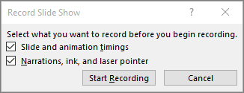
More about these options:
  - Slide and animation timings: PowerPoint automatically records the time you spend on each slide, including any animation steps that occur, and the use of any triggers on each slide.
  - Narrations, ink, and laser pointer: Record your voice as you run through your presentation. If you use the pen, highlighter, eraser, or laser pointer, PowerPoint records those for playback as well.
Important: Pen, highlighter, and eraser recording are available only if you have the February 16, 2015 update for PowerPoint 2013 or a later version of PowerPoint installed. In earlier versions of PowerPoint, pen and highlighter strokes are saved as ink annotation shapes.
- At the top left corner of the window is the Recording toolbar, which you can use to:
  - Go to the next slide:
  - Pause the recording:
  - Re-record the current slide:
If you re-record your narration (including audio, ink, and laser pointer), PowerPoint erases your previously recorded narration (including audio, ink, and laser pointer) when you start recording again on the same slide.
You can also re-record by going to Slide Show > Record Slide Show.
- To use ink, eraser, or the laser pointer in your recording, right-click the slide, click Pointer options, and pick your tool:
  - Laser Pointer
  - Pen
  - Highlighter
  - Eraser (This option is grayed out unless you have previously added ink to some slides.)
To change the color of the ink, click Ink Color.
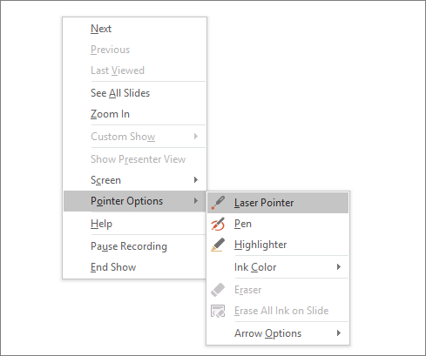
- To end your recording, right-click the final slide, and click End Show.
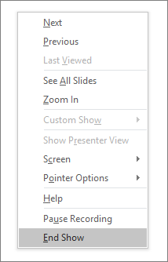
Tip: When you finish recording your narration, a sound icon appears in the lower-right corner of each slide that has narration.
The recorded slide show timings are automatically saved. Timings are shown in Slide Sorter view just beneath each slide.
In this process, what you record is embedded in each slide, and the recording can be played back in Slide Show. A video file is not created by this recording process. However, if you want a video file, you can save your presentation as a video with a few extra steps.

Preview the recorded slide show
On the Slide Show tab, click From Beginning or From Current Slide.
During playback, your animations, inking actions, laser pointer, audio and video play in sync.
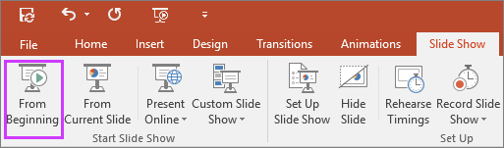

Preview the recorded audio
In Normal view, click the sound icon in the lower-right corner of the slide, and then click Play.
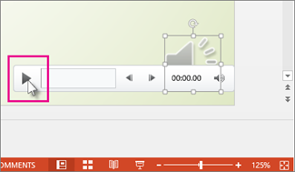

Set the slide timings manually
PowerPoint automatically records your slide timings when you add narrations, or you can manually set the slide timings to accompany your narrations.
- In Normal view, click the slide that you want to set the timing for.
- On the Transitions tab, in the Timing group, under Advance Slide, select the After check box, and then enter the number of seconds indicating how long the slide should appear on the screen. Repeat the process for each slide that you want to set the timing for.
Tip: If you want the next slide to appear either when you click the mouse or automatically after the number of seconds that you enter—whichever comes first—select both the On Mouse Click and the Aftercheck boxes.

Delete timings or narration
The Clear command is for deleting timings or narration from your recording that you don't want or that you want to replace. There are four different Clear commands that allow you to:
- Delete the timings on the currently selected slide
- Delete the timings on all slides at once
- Delete the narration on the currently selected slide
- Delete the narration on all slides at once
- If you do not want to delete all the timings or narration in your presentation, open a specific slide that has a timing or narration that you do want to delete.
- On the Slide Show tab of the PowerPoint ribbon, on the Record Slide Show button, click the down arrow, point to Clear, and then choose the appropriate Clear command for your situation.

Turn off timings or turn off narrations, ink, and laser pointer
After you've recorded your PowerPoint presentation, any timings, gestures, and audio you performed are saved on the individual slides. But you can turn them all off if you want to view the slide show without them:
- To turn off recorded slide timings: On the Slide Show tab, clear the Use Timings box.
- To turn off recorded narrations, ink, and the laser pointer: On the Slide Show tab, clear the Play Narrations box.

See also
Turn your mouse into a laser pointer
Animate text or objects
Turn your presentation into a video
Create a self-running presentation

Recording tips
- Recordings are added to the presentation on a per-slide basis, so if you want to change a recording, you only have to re-record the affected slide or slides. Also, you can rearrange the order of slides after recording without having to re-record anything. This also means it's easy to pause for a break while recording a presentation.
- PowerPoint doesn't record audio or video during transitions between slides, so don't speak while advancing the slide. Also, include a brief buffer of silence at the beginning and the end of each slide to make the transitions smooth and ensure that you don't cut off audible narration while transitioning from one slide to the next.
- You can't record narration in PowerPoint Online. Use a desktop version of PowerPoint to record your narration.
- You can adjust and edit the size of video and ink in edit view.
- If it's possible that your audience may use PowerPoint Online to experience the recording, use the transitions that are supported by PowerPoint Online (Cut, Fade, Push, Wipe, Split, Random Bars, Shape, Morph).
- Presentation recording works best with touch-screen PCs that have a web camera.
- Use video preview to make sure everything is set up correctly before recording.
- For slides that you want to record gestures (such as ink) on, make multiple copies of the slide so that you can easily record multiple takes. Then delete the extraneous slides when you're done.
- Record a few seconds of silence by turning off audio and video to advance after a set time.
- For higher quality, use an external web cam and/or microphone.
Built-in cameras and microphones are suitable for most tasks. But if you want more professional-looking video, consider using an external web cam, if you're able. If you're using PowerPoint on a tablet or laptop and you're inking with a stylus, an external camera and microphone allows you to minimize stylus noise.
- As soon as you finish your first slide recording, play it back.
Before you get too far down the road of recording your presentation, make sure your audio and video sound and look the way you expect.

