Set a password in a Word document
To encrypt your file and set a password to open it:
- Click the Microsoft Office Button , point to Prepare, and then click Encrypt Document.
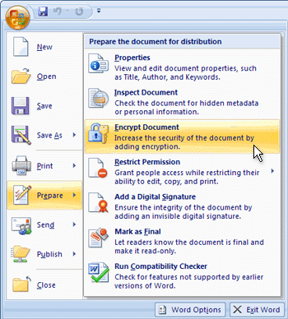
- In the Encrypt Document dialog box, in the Password box, type a password, and then click OK.
CAUTION: Keep your password in a safe place. If you lose or forget the password, it can't be recovered.
You can type up to 255 characters. By default, this feature uses AES 128-bit advanced encryption. Encryption is a standard method used to help make your file more secure.
- In the Confirm Password dialog box, in the Reenter password box, type the password again, and then click OK.
- To save the password, save the file.

