The Twitter glossary
The Twitter glossary includes vocabulary and terminology used to talk about features and aspects of Twitter.

@
The @ sign is used to call out usernames in Tweets: "Hello @twitter!" People will use your @username to mention you in Tweets, send you a Direct Message or link to your profile.

@username/handle
A username is how you're identified on Twitter, and is always preceded immediately by the @ symbol. For instance, Twitter Support is @TwitterSupport. – You can have up to 15 characters in a name.

#/hashtag
A hashtag is any word or phrase immediately preceded by the # symbol. When you click or tap on a hashtag, you'll see other Tweets containing the same keyword or topic.

Alerts
Twitter Alerts enable public safety agencies to inform people during emergencies by highlighting critical time-sensitive content with notifications and a unique look.

bio
Your bio is a short (up to 160 characters) personal description that appears in your profile that serves to characterize your persona on Twitter.

block
If you block a Twitter account, that account will be unable to follow you or add you to their Twitter lists, and you will not receive a notification if they mention you in a Tweet.

bug
An internal error in our site code and functionality. If you see one, please point it out to @TwitterSupport by sending us a message.

cashtag
A cashtag is a company ticker symbol preceded by the U.S. dollar sign, e.g. $TWTR. When you click on a cashtag, you'll see other Tweets mentioning that same ticker symbol.

Connect tab
A personalized experience providing a fast and easy way to connect you to accounts you may be interested in, or to reconnect you with old friends on Twitter through your device’s address book.

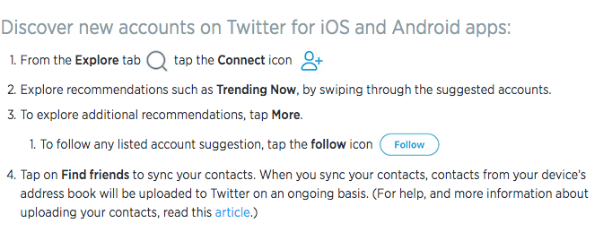

deactivation
If you deactivate your account, it goes into a queue for permanent deletion from Twitter in 30 days. You may reactivate your account within the 30 day grace period.

Direct Messages
Direct Messages are private messages sent from one Twitter account to another account(s). You can use Direct Messages for one-on-one private conversations, or between groups.

follow
Subscribing to a Twitter account is called “following.” To start following, click or tap the Follow icon next to the account name on their profile to see their Tweets as soon as they post something new. Anyone on Twitter can follow or unfollow anyone else at any time, with the exception of blocked accounts.

follow(s)
A follow is the result of someone following your Twitter account. You can see how many follows (or followers) you have from your Twitter profile.

follow count
This count reflects how many people you follow and how many follow you; these numbers are found on your Twitter profile.

follower
A follower is another Twitter account that has followed you to receive your Tweets in their Home timeline.

geolocation, geotagging
Adding a location to your Tweet (a geolocation or geotag) tells those who see your Tweet where you were when you posted that Tweet.

hacking
Gaining unauthorized access to an account via phishing, password guessing, or session stealing. Usually this is followed by unauthorized posts from the account. Hacked accounts are sometimes referred to as "compromised."

header photo
Your personal image that you upload, which appears at the top of your profile.

Home
Your Home timeline displays a stream of Tweets from accounts you have chosen to follow on Twitter.

impersonation
Online impersonation (pretending to be someone you're not) that is intended to deceive is prohibited under the Twitter Rules. Parody accounts are allowed. See "parody".

like (n.)
Liking a Tweet indicates that you appreciate it. You can find all of your likes by clicking or tapping the Likes tab on your profile.

like (v.)
Tap the heart icon to like a Tweet and the author will see that you appreciate it.

list
From your own account, you can create a group list of other Twitter accounts by topic or interest (e.g., a list of friends, coworkers, celebrities, athletes). Twitter lists also contain a timeline of Tweets from the specific accounts that were added to the list, offering you a way to follow individual accounts as a group on Twitter.

mention
Mentioning other accounts in your Tweet by including the @ sign followed directly by their username is called a “mention”. Also refers to Tweets in which your @username was included.

mobile web
Twitter's website tailored to fit your mobile device. Visit it at mobile.twitter.com. When you visit mobile.twitter.com from a smartphone or tablet, you’ll experience the data-friendly Twitter Lite.

mute
You can mute accounts
To mute an account
Muting from a Tweet:
From a Tweet, click the icon
Click Mute.
Muting from a profile:
Go to the profile page of the person you wish to mute.
Click the overflow icon on their profile page.
Select Mute from the options listed.
Once you’ve muted an account on the web, you will see a confirmation banner. If you made a mistake, you can click Undo to unmute the account.

mute words, phrases, usernames and hashtags from your notifications; and mute Direct Message notifications.

night mode
Night mode for Twitter features a dark-colored palette that is optimized for experiencing Twitter comfortably in low-light situations. The night mode feature is available on twitter.com, Twitter for iOS, and Twitter for Android.

Notifications, notifications
The Notifications timeline displays your interactions with other Twitter accounts, like mentions, likes, Retweets and who has recently followed you. If you request it, we send notifications to you via email, SMS, or through the Twitter for iOS or Twitter for Android apps.

parody
You can create parody accounts on Twitter to spoof or make fun of something in jest, as well as commentary and fan accounts. These accounts must disclose that they are parody, fan or commentary accounts in order to comply with our strict policy against impersonation.

phishing
Tricking someone to give up their username and password. This can happen by sending someone to a fake sign-in page, a page promising to get more followers, or just simply asking for the username and password through Direct Message or email.

pinned Tweets
You can pin one of your Tweets to the top of your profile page to keep it above the flow of time-ordered Tweets.

profile
Your profile displays information you choose to share publicly, as well as all of the Tweets you've posted. Your profile along with your @username identify you on Twitter.

profile photo
The personal image associated with your account. It's also the picture that appears next to each of your Tweets.

Promoted Accounts
Promoted Accounts present suggested accounts you might want to follow as promoted by our advertisers. These appear in your Home timeline, and via Who to Follow, search results and elsewhere on the platform.

Promoted Moments
Promoted Moments are Moments that are authored by a brand and featured in the Moments guide. They are clearly marked as “Promoted”.

Promoted Trends
Promoted Trends display time-, context-, and event-sensitive trends promoted by our advertisers. These appear at the top of the Trending Topics list on Twitter and elsewhere on the platform, and are clearly marked as "Promoted".

Promoted Tweets
Promoted Tweets are Tweets that are paid for by our advertisers. These appear in your Home timeline, at the top of search results on Twitter and elsewhere on the platform, and are clearly marked as "Promoted".

Promoted Videos
Promoted Videos are videos within Promoted Tweets that are paid for by our advertisers. These appear in your Home timeline, at the top of search results on Twitter, and elsewhere on the platform, and are clearly marked as "Promoted”.

protected Tweets
Tweets are public by default. Choosing to protect your Tweets means that your Tweets will only be seen by your followers.

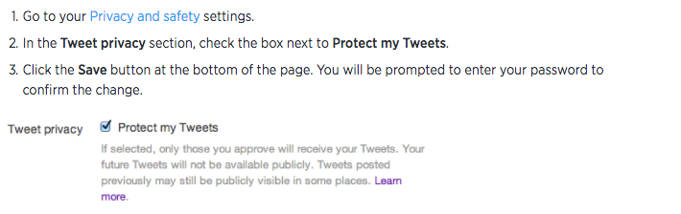

reply
A response to another person’s Tweet. Reply by clicking or tapping the reply icon next to the Tweet you'd like to respond to. A direct reply count is displayed next to the reply icon of a Tweet, and indicates the total number of replies the Tweet has received.

reactivation
You may reactivate a deactivated account within 30 days of the deactivation date. After 30 days, deactivated accounts are permanently deleted.

Retweet (n.)
A Tweet that you forward to your followers is known as a Retweet. Often used to pass along news or other valuable discoveries on Twitter, Retweets always retain original attribution.

Retweet (v.)
The act of sharing another account's Tweet to all of your followers by clicking or tapping on the Retweet button.

SMS
Short Message Service (SMS) is most commonly known as text messaging.

short code
A five-digit phone number used to send and receive Tweets via text message.
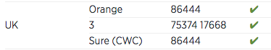

spam
Refers to a variety of prohibited behaviours that violate the Twitter Rules. Spam can be generally described as unsolicited, repeated actions that negatively impact other accounts.

suspended
Suspended accounts have been prohibited from using Twitter, generally for breaking Twitter Terms of Service.

text commands
When using Twitter via SMS, these commands allow you to access most Twitter features with simple text keywords. Learn the Twitter text commands.

timeline
A timeline is a real-time stream of Tweets. Your Home timeline, for instance, is where you see all the Tweets shared by your friends and other people you follow.

timestamp
The date and time a Tweet was posted to Twitter. A Tweet's timestamp can be found in grey text in the detail view of any Tweet.

top Tweets
Tweets determined by a Twitter algorithm to be the most popular or resonant on Twitter at any given time. Read more about top Tweets.

trends
A Trend is a topic or hashtag determined algorithmically to be one of the most popular on Twitter at that moment. You can choose to tailor Trends based on your location and who you follow.

Tweet (n.)
A Tweet may contain photos, GIFs, videos, links, and text.

Tweet (v.)
The act of sending a Tweet. Tweets get shown in Twitter timelines or are embedded in websites and blogs.

Tweet button
Anyone can add a Tweet button to their website. Clicking this button lets people on Twitter post a Tweet with a link to that site. Learn how to add the Tweet button to your website here.

Twitter
An information network made up of short messages (including photos, GIFs, videos, and links) from all over the world. Sign up for an account.

Twitter emoji
A Twitter emoji is a specific series of letters immediately preceded by the # sign which generates an icon on Twitter such as a national flag or another small image.
https://emojipedia.org/twitter/

Twitter Polls
Twitter Polls allow you to weigh in on questions posed by other people on Twitter. You can also easily create your own poll and see the results instantly.

URL, URLs
A URL (Uniform Resource Locator) is a web address that points to a unique page on the internet.

verification
A process whereby a Twitter account receives a blue check icon to indicate that the creator of these Tweets is a legitimate source. Verified accounts include public figures and those who may have experienced identity confusion on Twitter.

who to follow
Who to follow is an automated list of recommended accounts we think you might find interesting, based on the types of accounts you already follow and who those people follow.

