Week 3 assignment: Social media marketing tactics
There are two options for this week; you can choose to work on one or both of them.
Option #1: Social media listening
Set up social media listening in Hootsuite (through search and/or keyword) for a brand, an institution, a celebrity or just any subject where there may be active related social media discussions.
You can look at Facebook, Twitter, Linkedin, Google+ etc
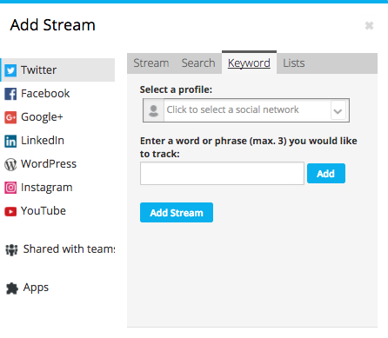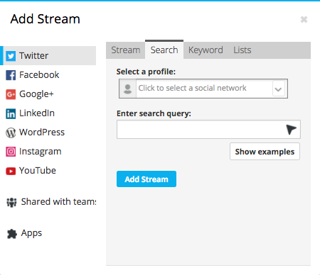

In your report, tell us what you listened to, what streams you set up, what you have found that interest or otherwise surprise you, and what you suggest that business or institution should do, and just anything else you want to discuss and share with us.
Option #2: Message creation
Choose a piece of content that you think may interest your followers/fans/customers.
Create a new tweet/LinkedIn post/Facebook post - conduct a hashtag research to find and include a few hashtags, then publish your message.
In your report, paste the actual tweet or post you created, tell us what specific guidelines you followed in drafting that message, how you came up with relevant hashtags, and tell us about responses to your message – look at the analytics, clicks, shares, etc.
For Example –

